# SECTION 22 – EJS – Embedded Javascript Templating

# App we will build in this module: **To Do list**

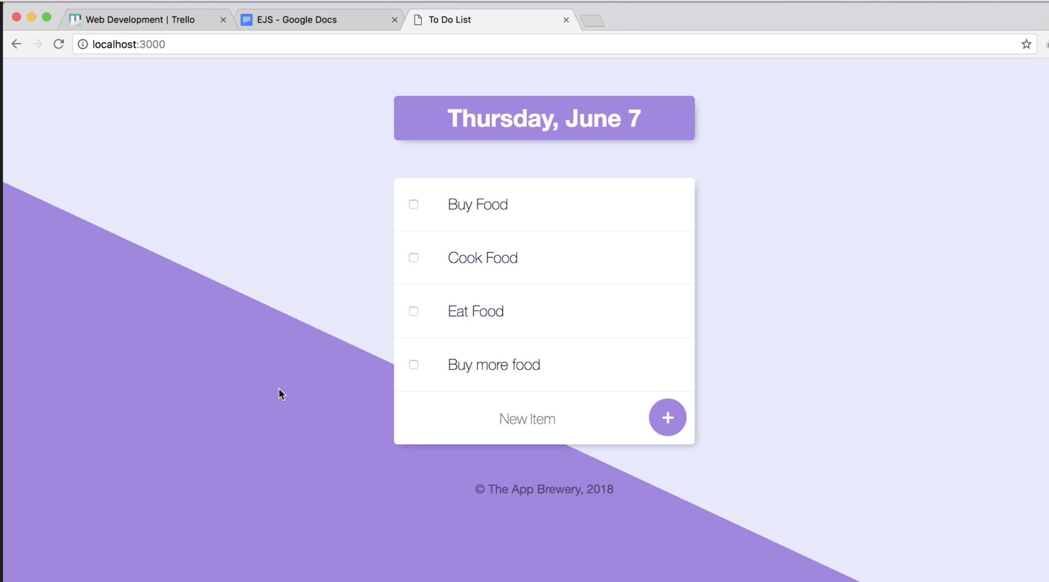

# Templates & why do we need templates?

## Practice the below to understand why we need:

Setup a node project: Steps

1. cd Documents/Web\Development => Switch to the project folder
2. mkdir todolist-v1 => Make project directory
3. cd todolist-v1 => Switch to project directory
4. touch index.html app.js => Create required files
5. npm init => Initialize npm in the project directory
6. npm install express body-parser => Install required packages
7. Atom . => Open in Atom editor

### Send plain text in response: using **send**

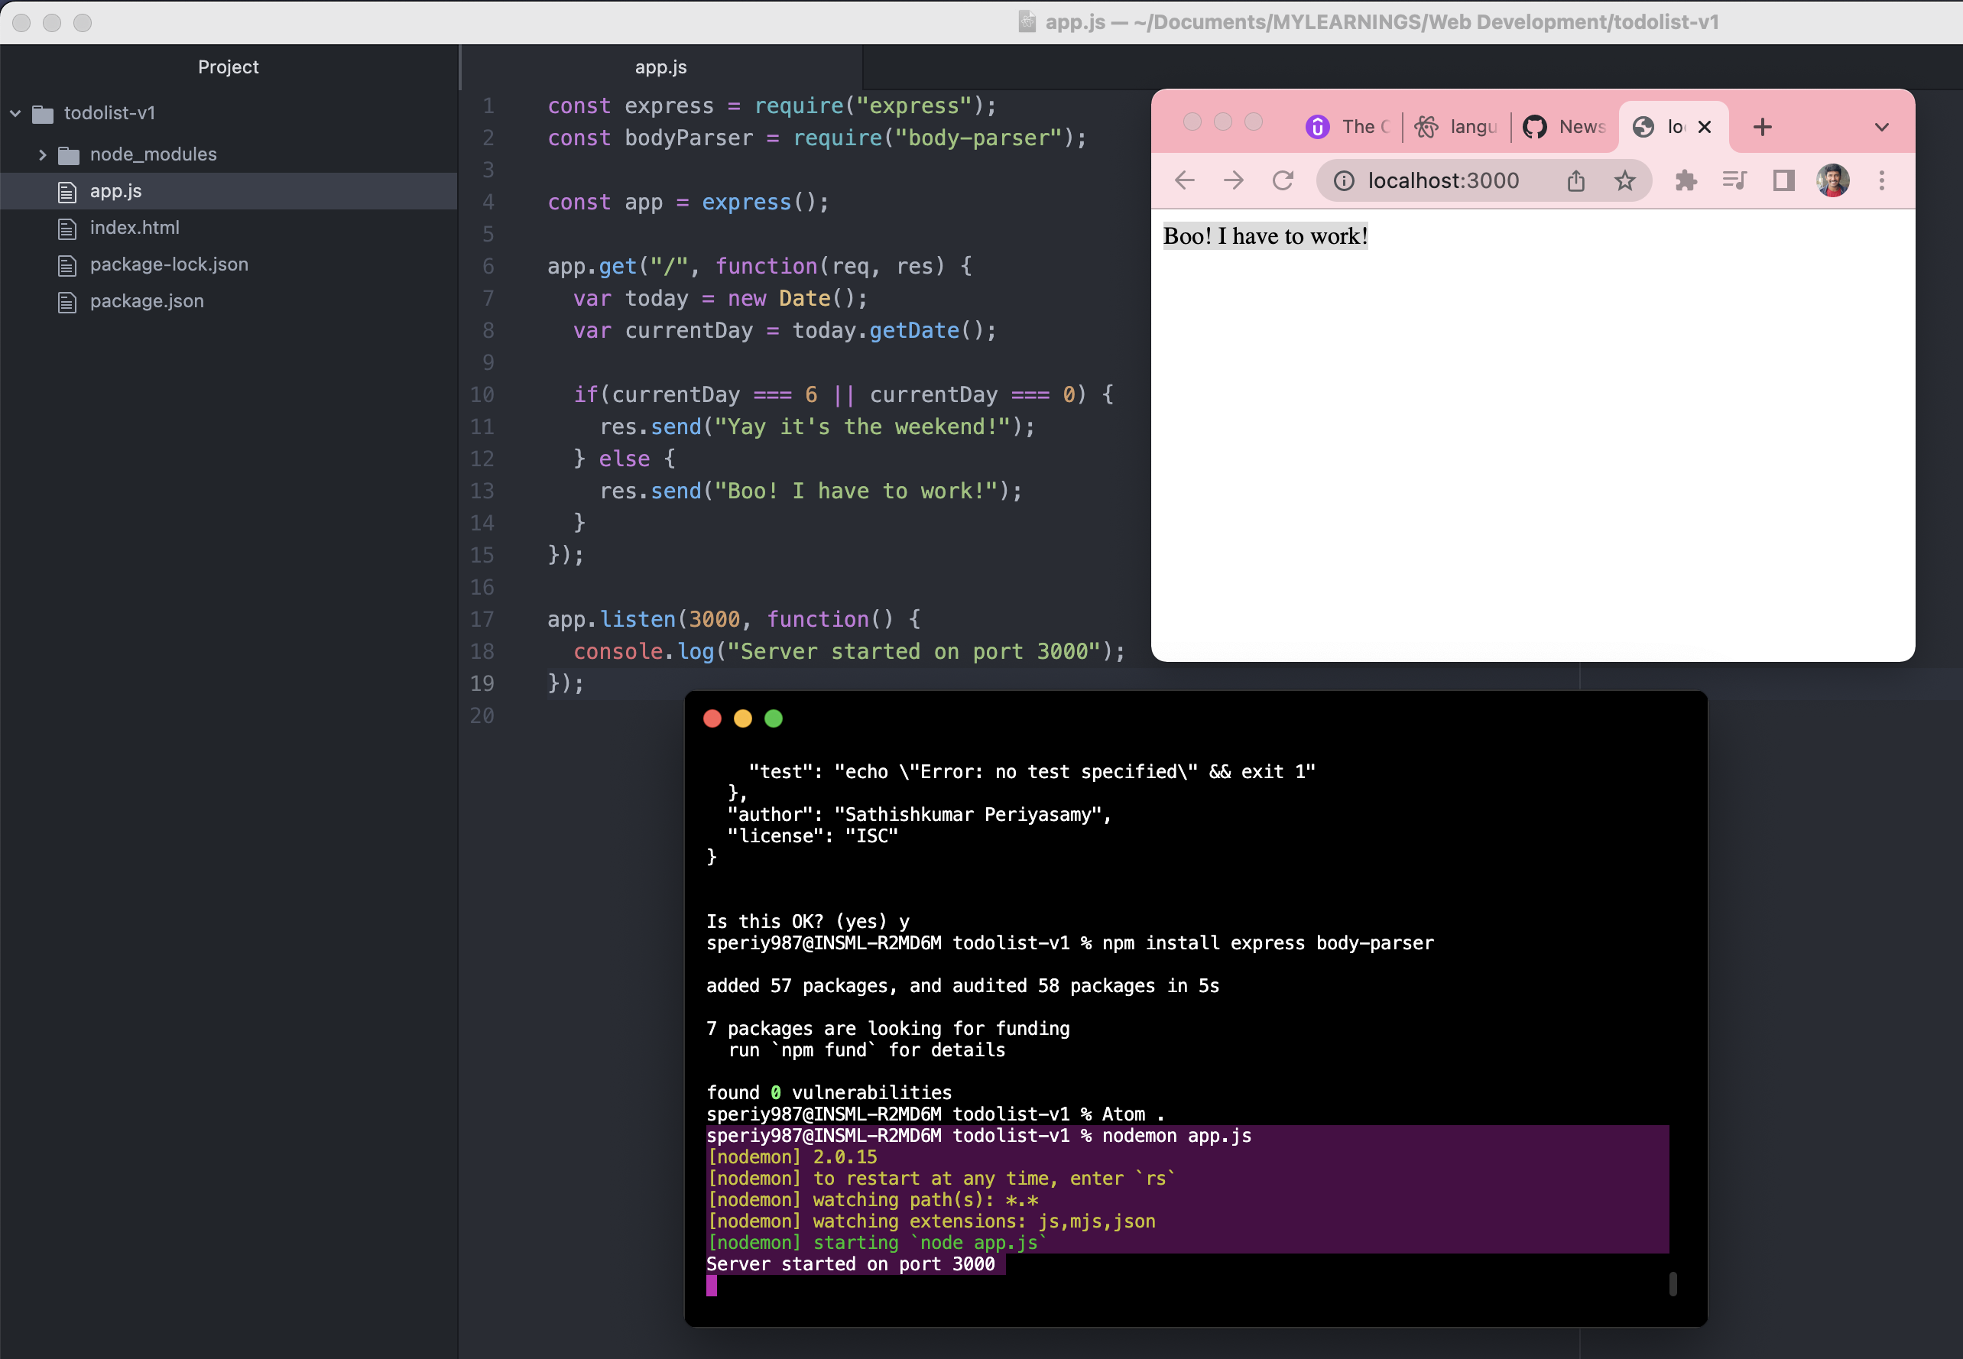

### Send html formatted text in response: using **send**

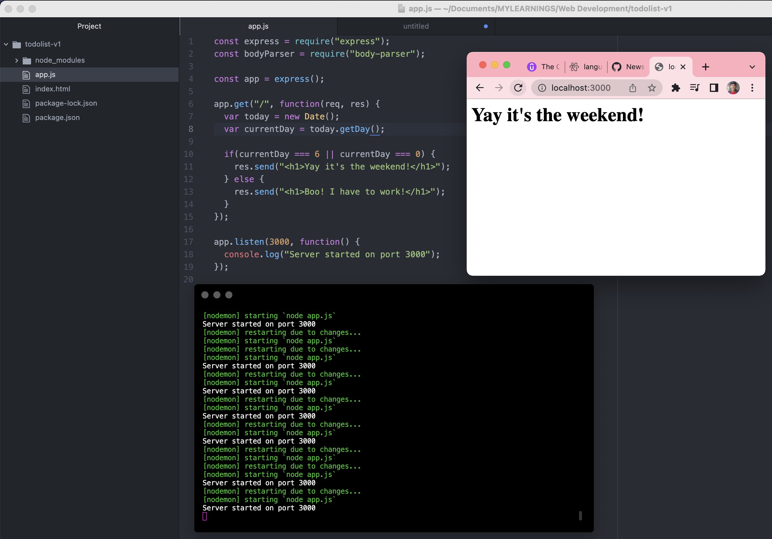

### Send multiple lines in response – using **write** andthen **send:**

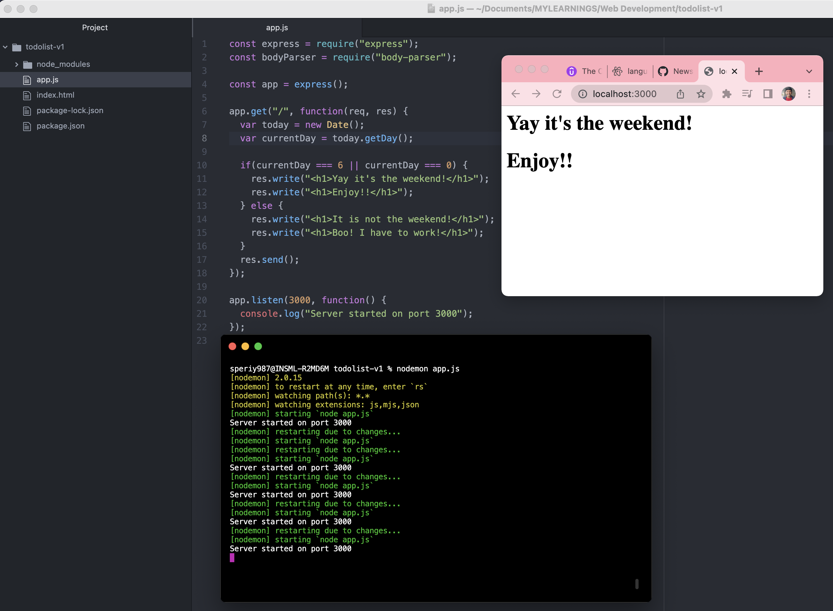

### Send html file in response – using **sendFile:**

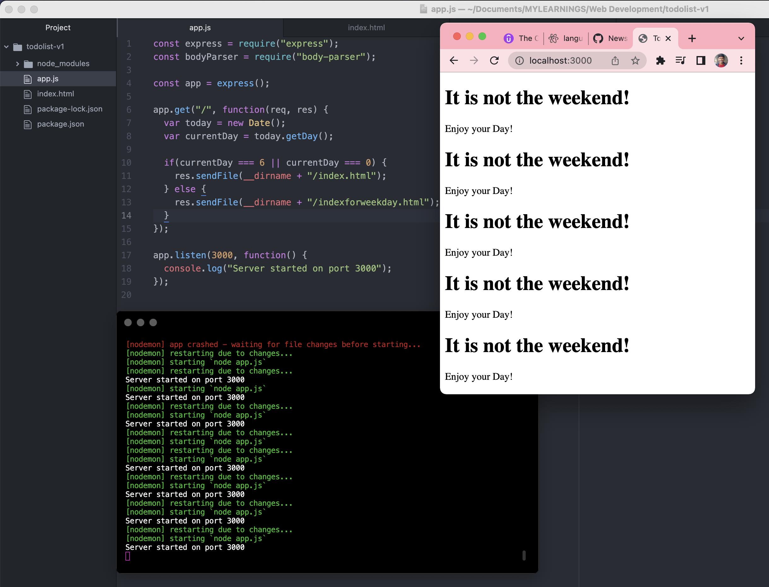

### Send multiple html files (OR) big html file (Say we want different messages for diff days) - ??????

SO WE NEED **TEMPLATES**

# EJS – Embedded Javascript Templating

One of the famous templating is ***EJS – Embedded Javascript*** templating language.

Documentation - <https://ejs.co/>

Using EJS with Express - <https://github.com/mde/ejs/wiki/Using-EJS-with-Express>

Marker/Syntax for EJS:

**<%=** *EJS* **%>**

Install EJS:

npm install ejs

Tags:

* <% 'Scriptlet' tag, for control-flow, no output
* <%_ ‘Whitespace Slurping’ Scriptlet tag, strips all whitespace before it
* _%> ‘Whitespace Slurping’ ending tag, removes all whitespace after it
* -%> Trim-mode ('newline slurp') tag, trims following newline
* <%= Outputs the value into the template (HTML escaped)
* <%- Outputs the unescaped value into the template
* <%# Comment tag, no execution, no output
* <%% Outputs a literal '<%'
* %> Plain ending tag

NOTE:  
EJS assumes views directory containing the ***<template>.ejs*** page.  
 app.set('view engine', 'ejs');

How to send EJS file in response:

app.get('/', (req, res) => {

res.render('index', {foo: 'FOO'});

});

Where,

index -> template filename present under views folder

foo -> marker variable in index.ejs file

FOO -> Value for foo marker variable

### **Creating our first EJS Template:**

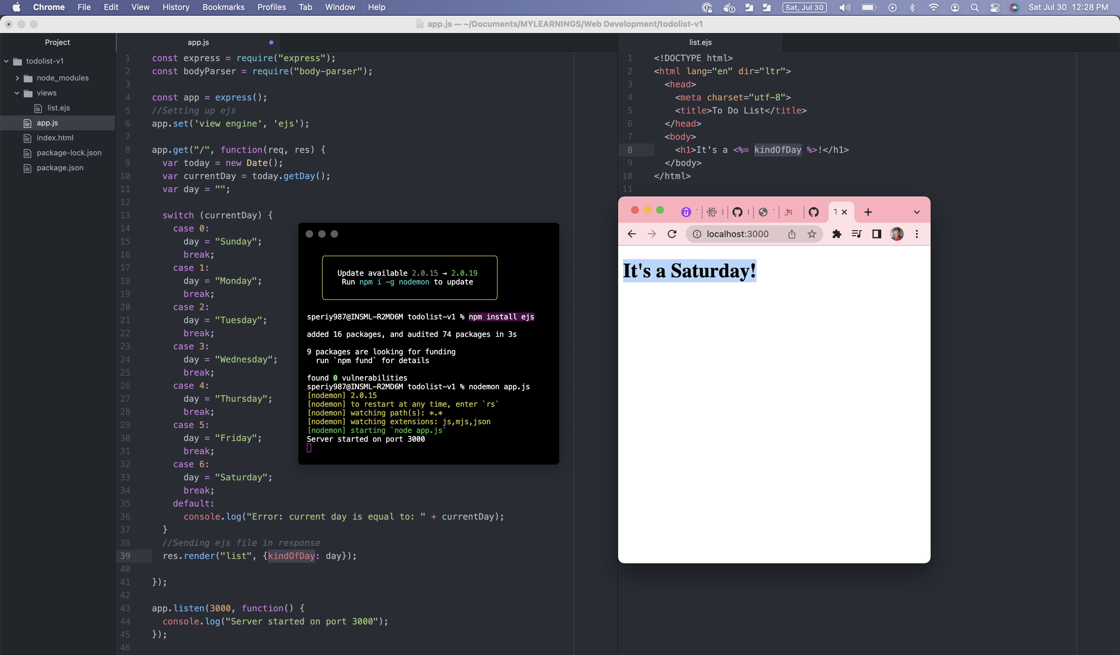  
NOTE: <%= Outputs the value into the template (HTML escaped)

**Running code inside the EJS Template:**

* Usually EJS is for html content file, but we can add control logics in .ejs file using **scriptlet** tag.
  + <% 'Scriptlet' tag, for control-flow, no output

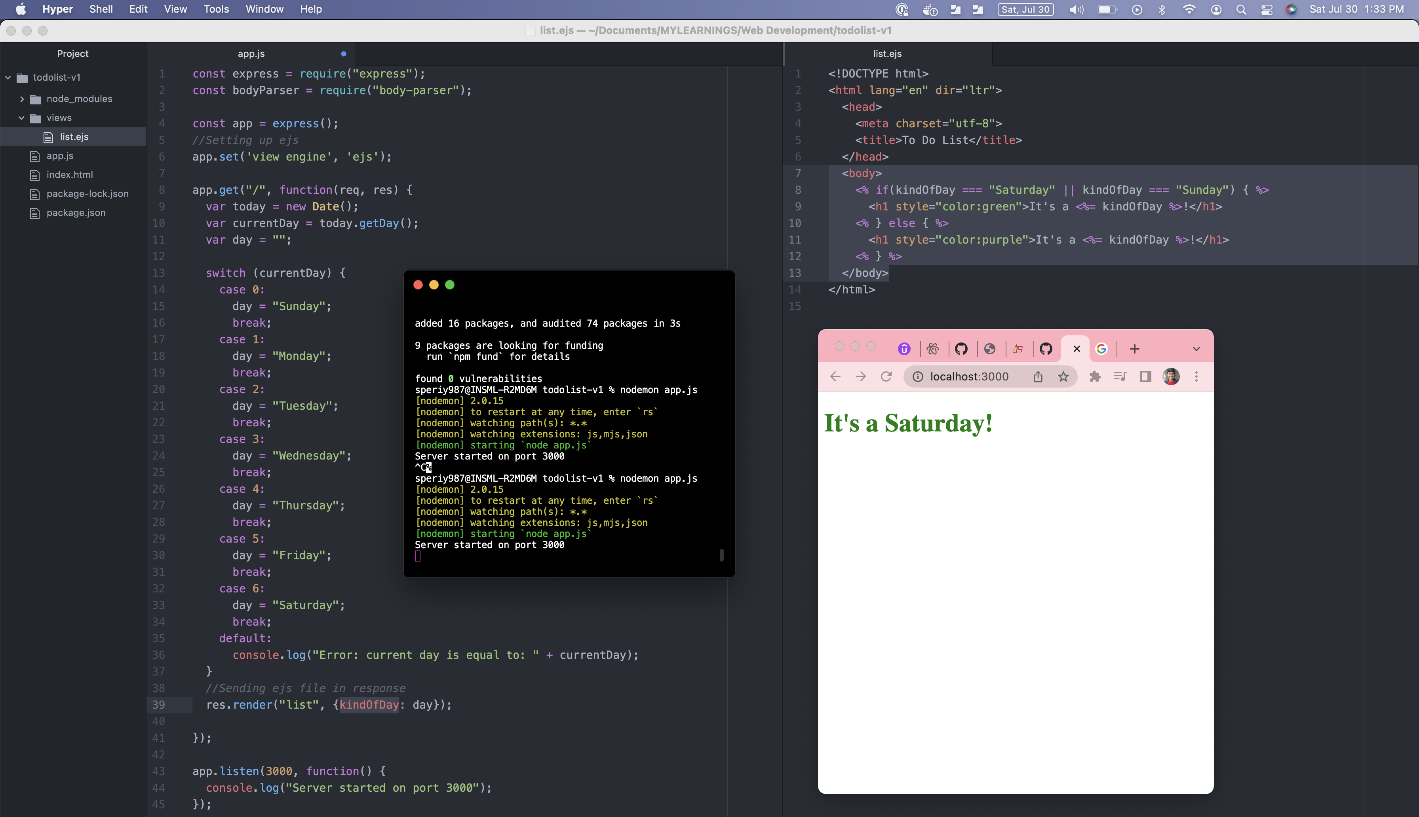

**Passing Data from our Webpage to our Server:**

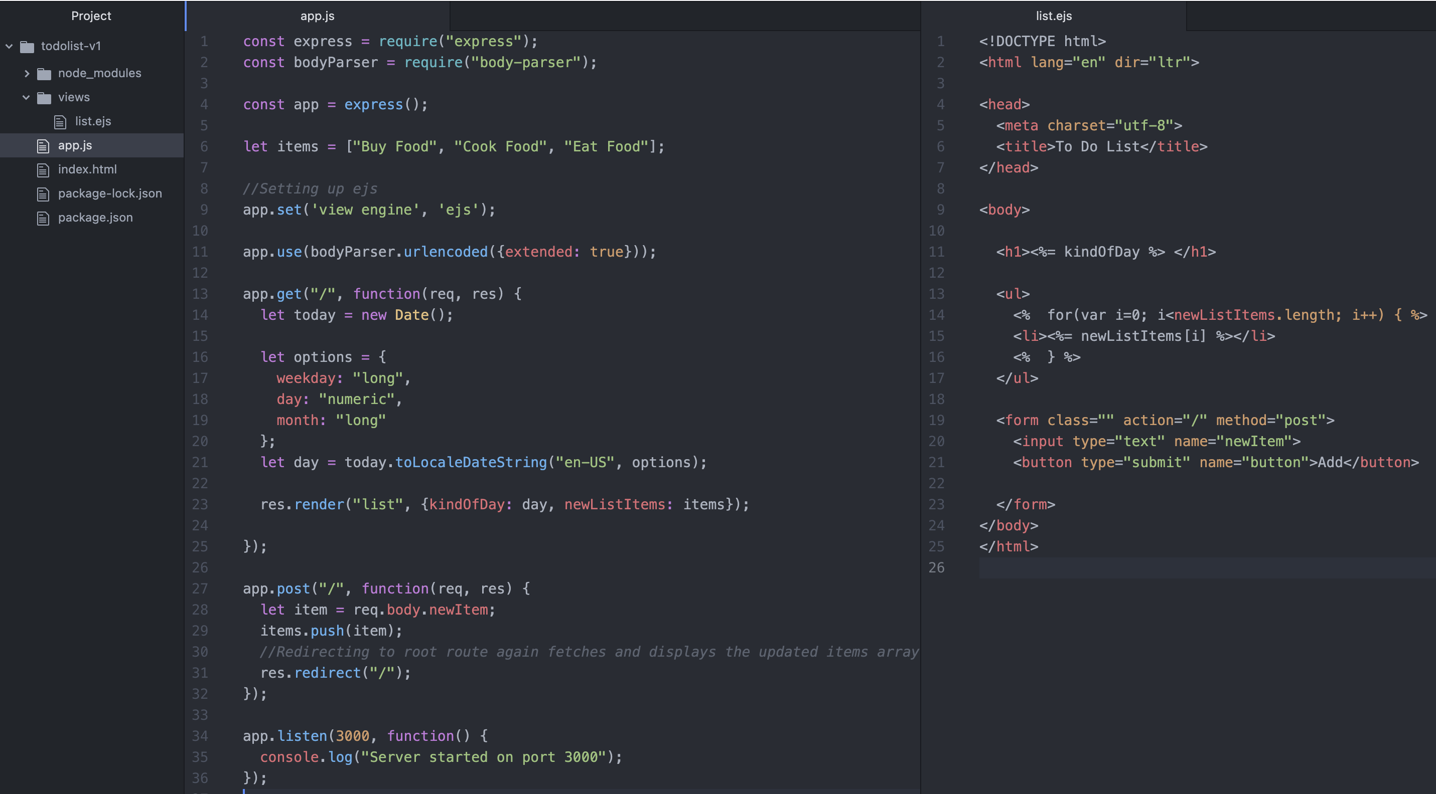

### **Adding premade CSS stylesheets to our website:**

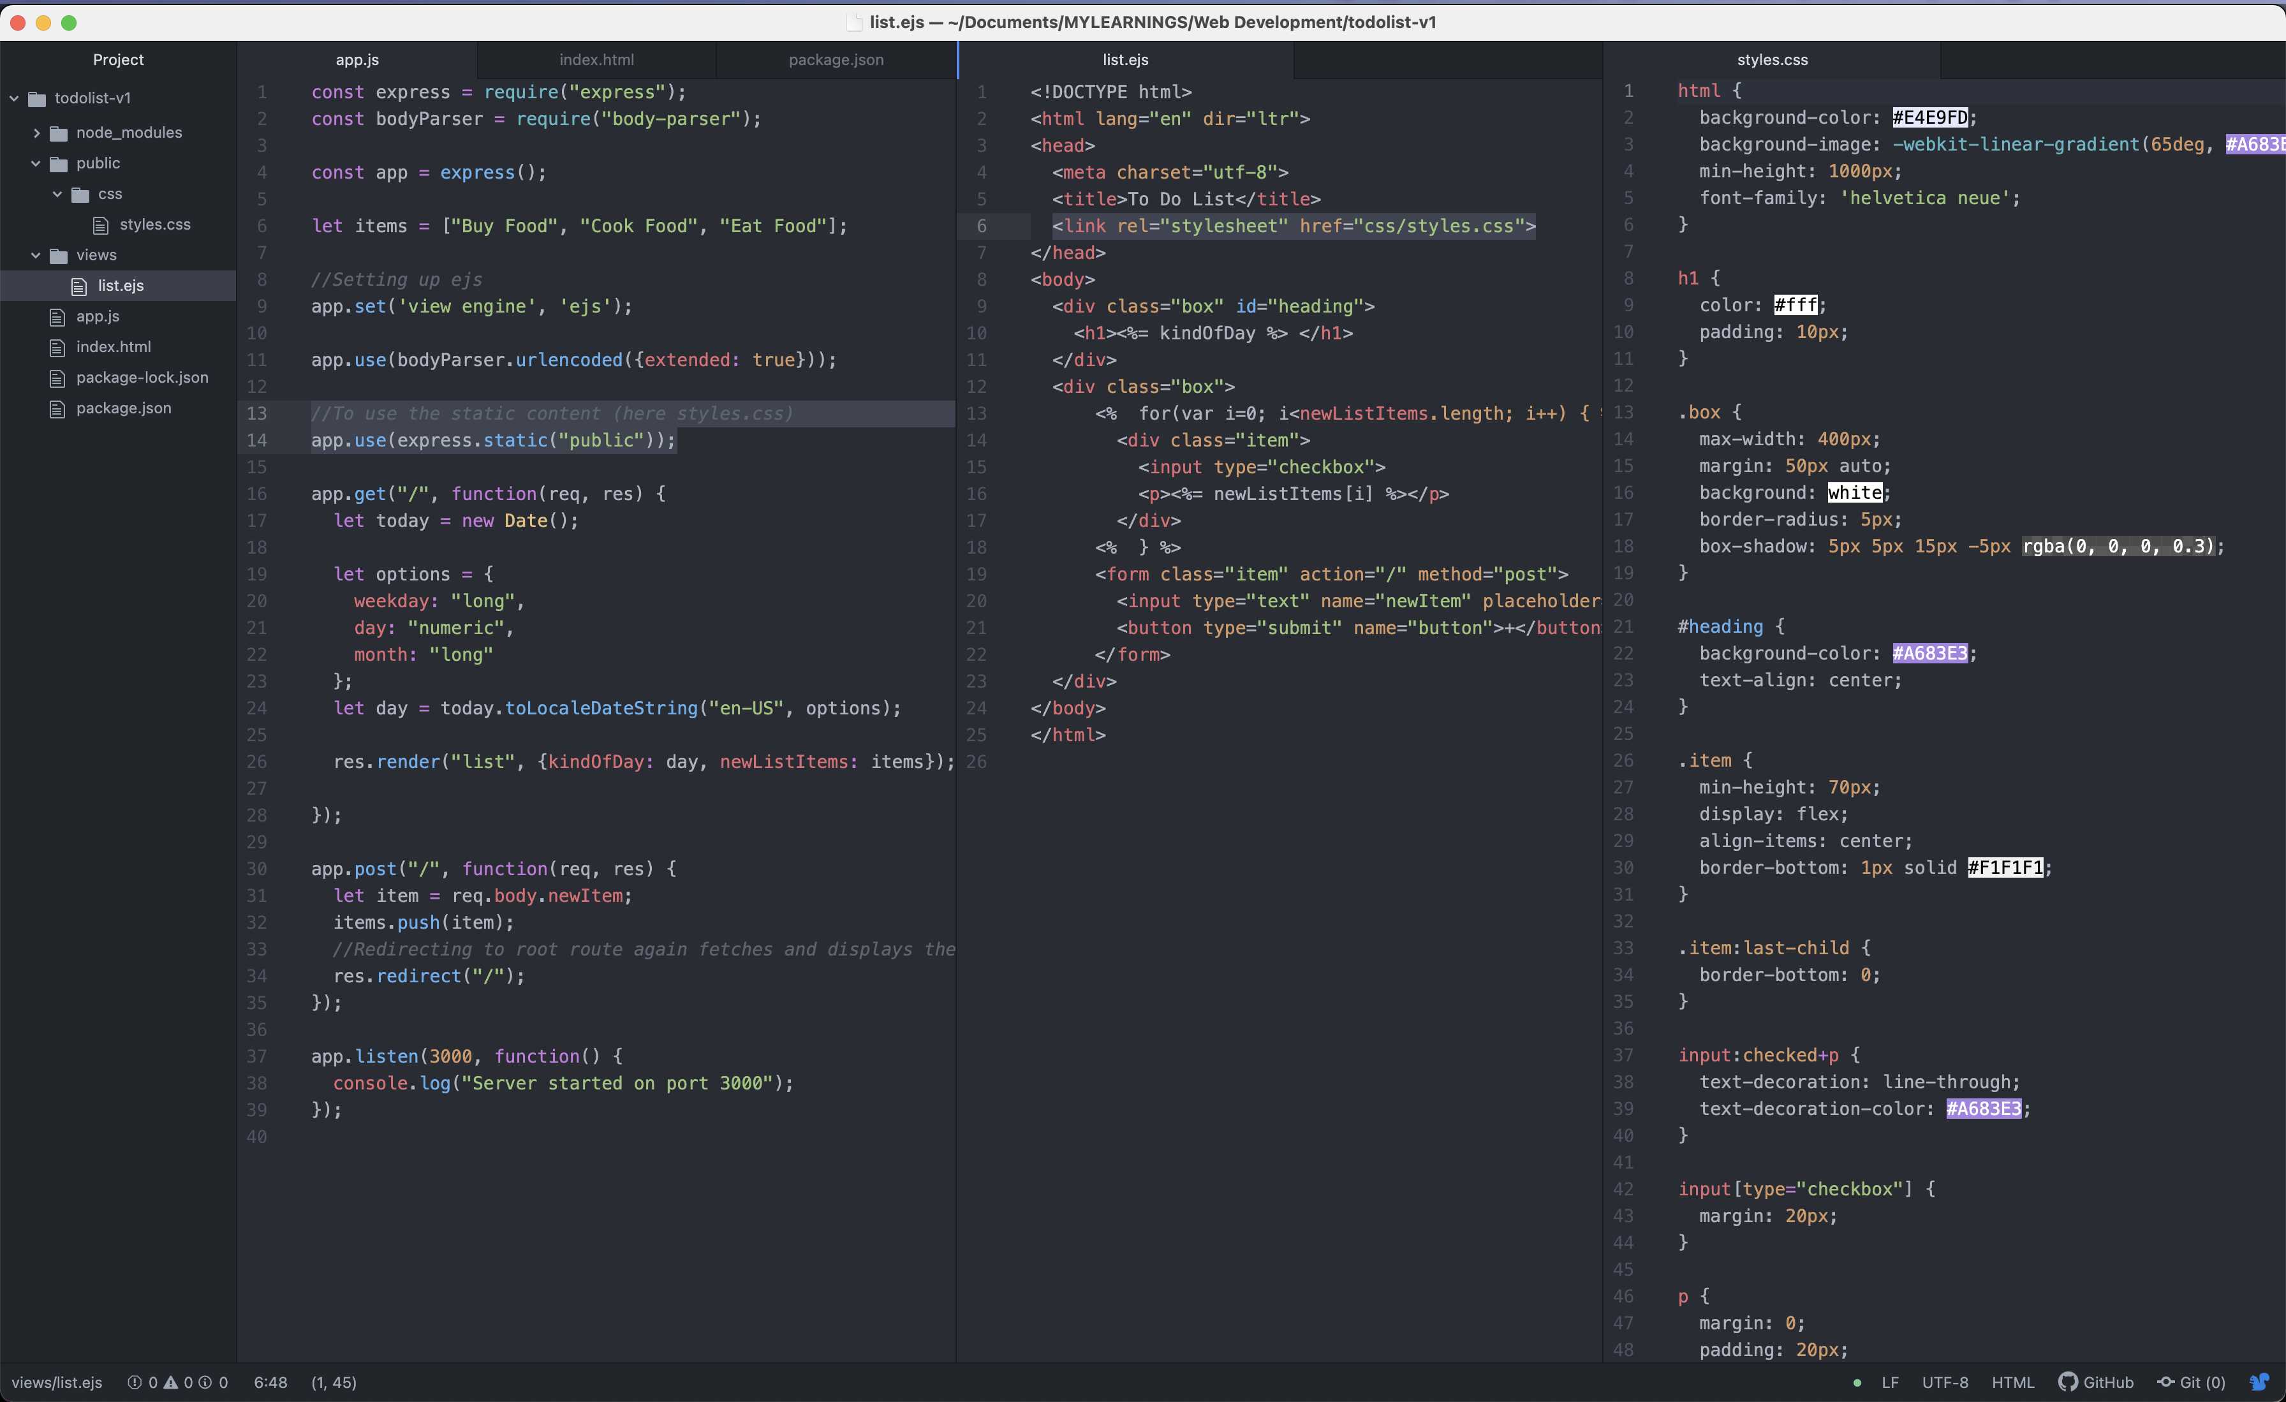

**Result:**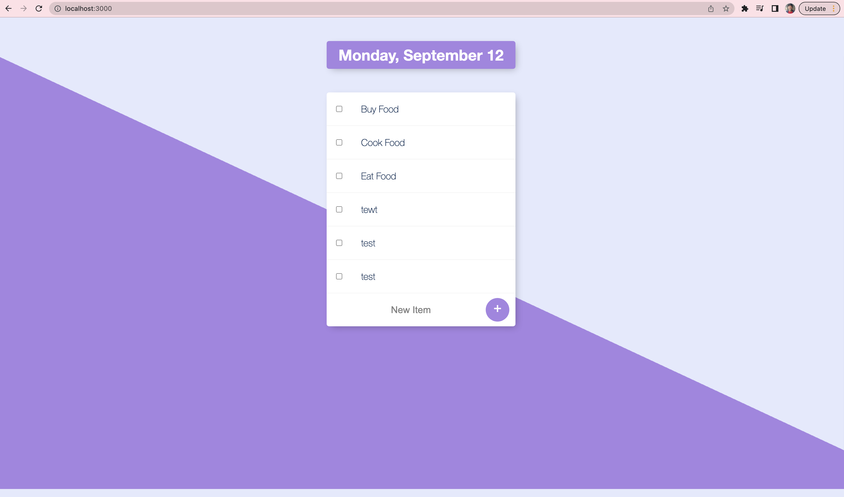

# **Reusing same template for different routes/pages: (which has similar structure probably)**

Eg: Todo (/) and work (/work) routes: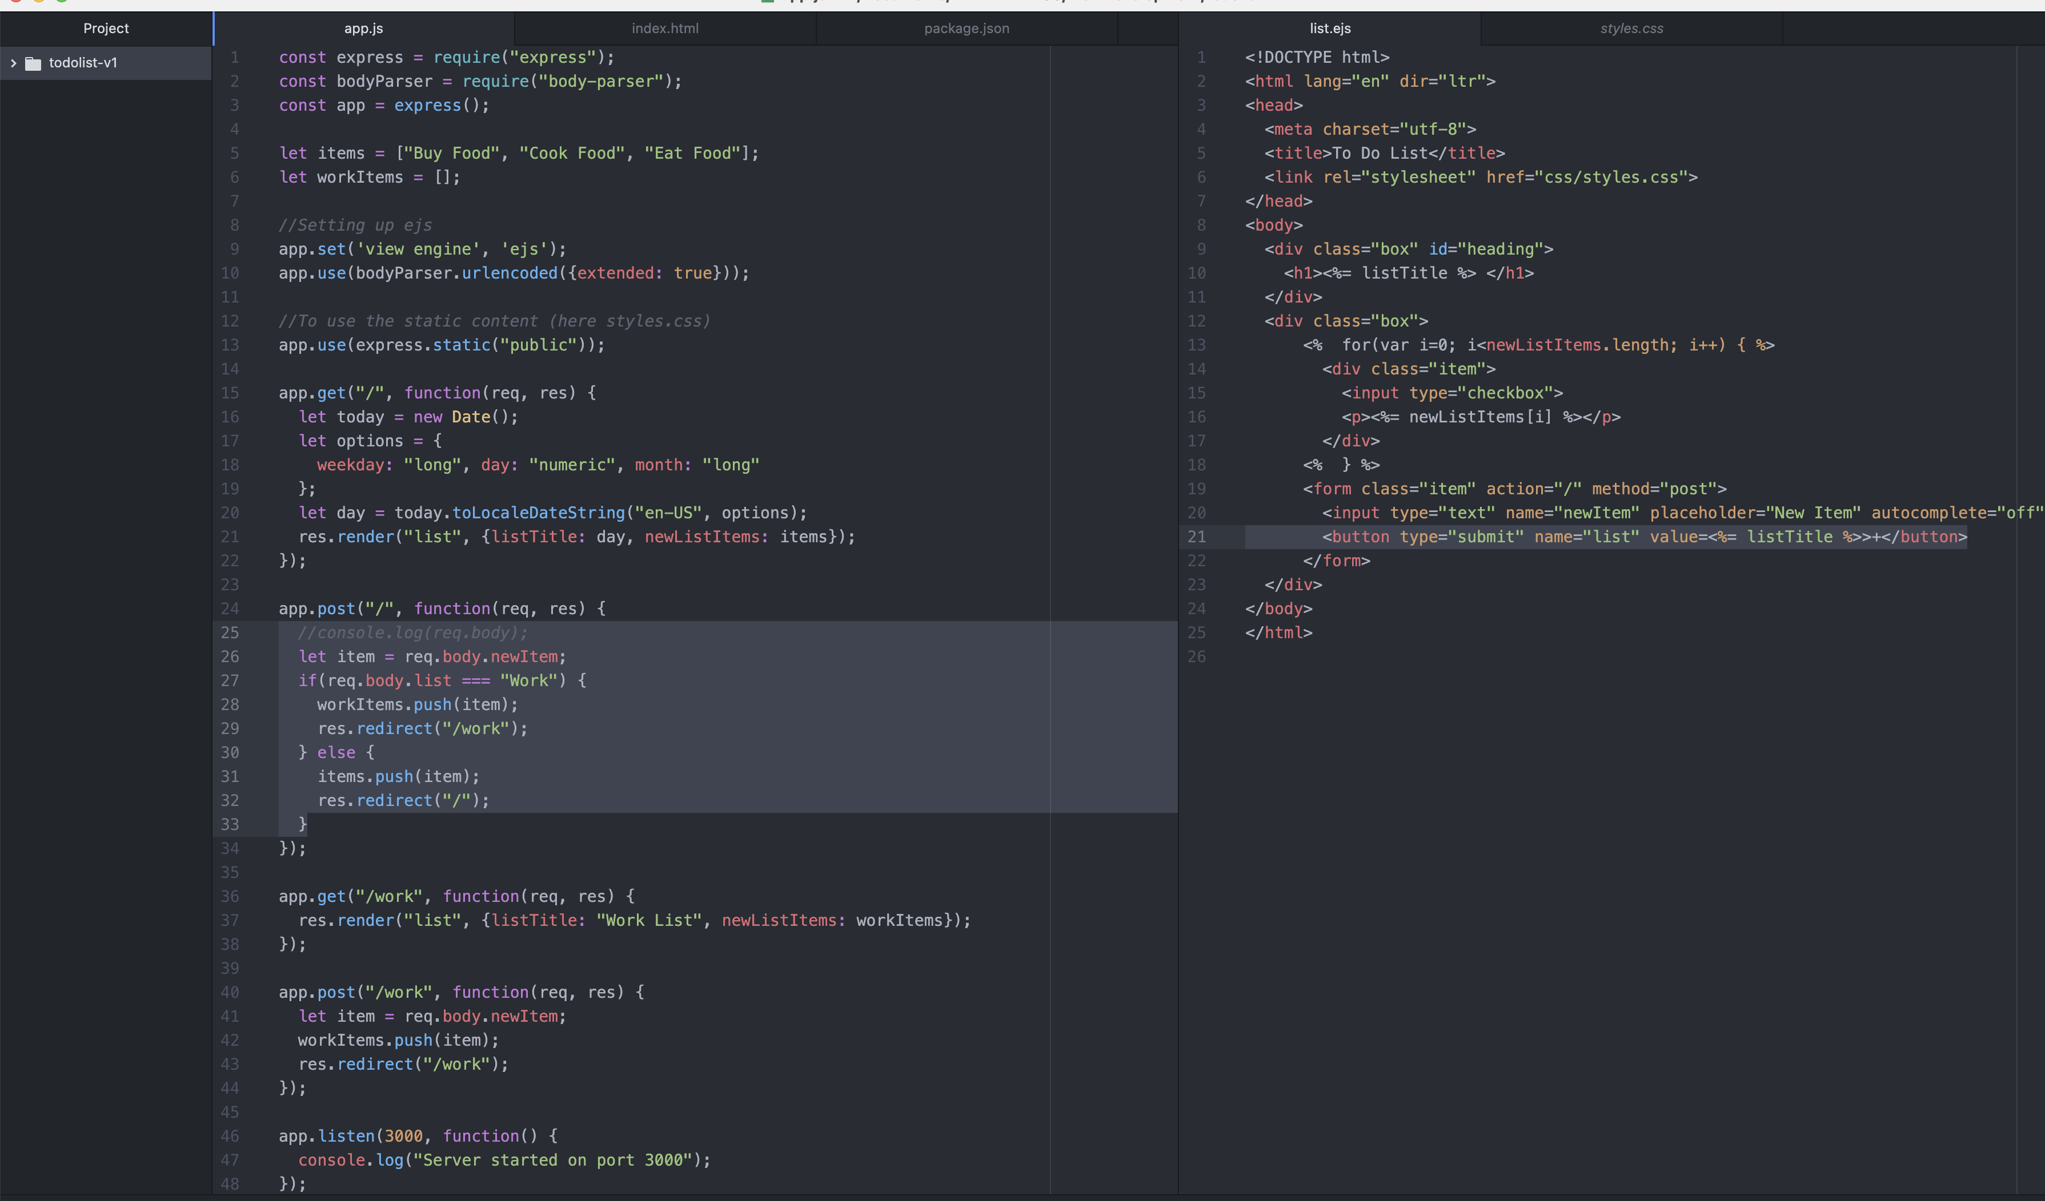

Result: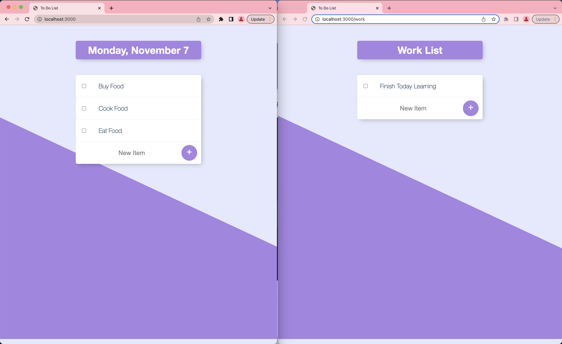

# **Templating vs Layouts:**

Even though we can reuse the template as above, it’s restricted to same structure. If we are having a view with different paradigm (Say, about me) but wanted to use the same background styling and all, we can use **Layouts.**

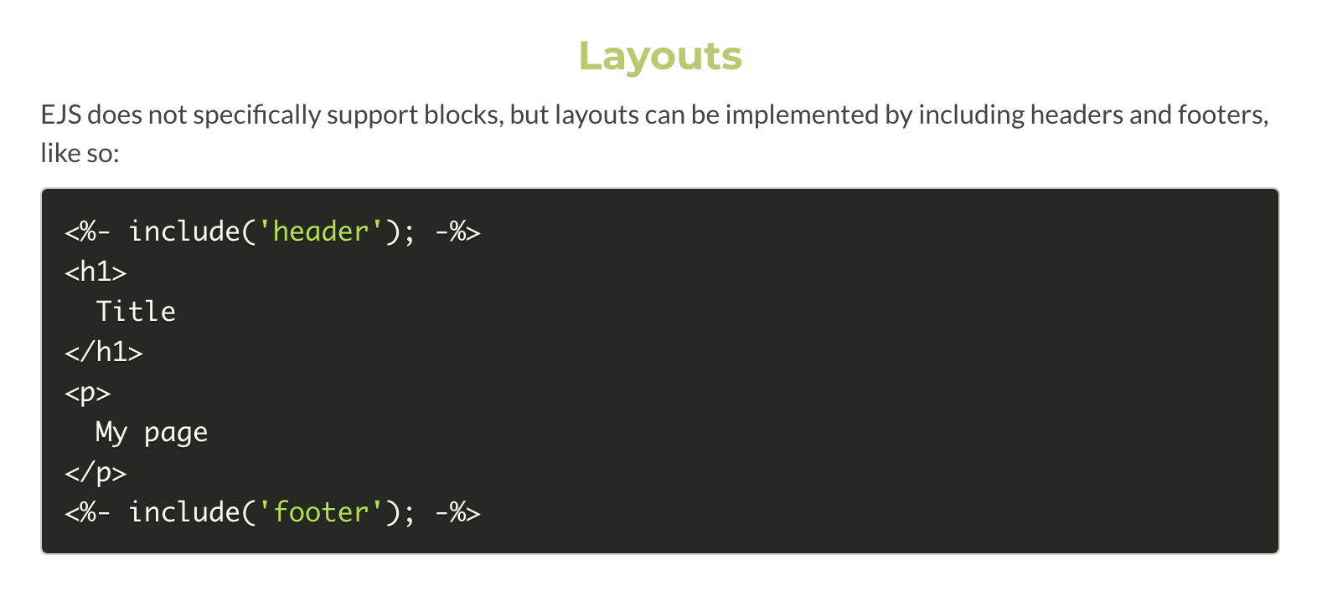

## **Implementation:**

## **Result:**

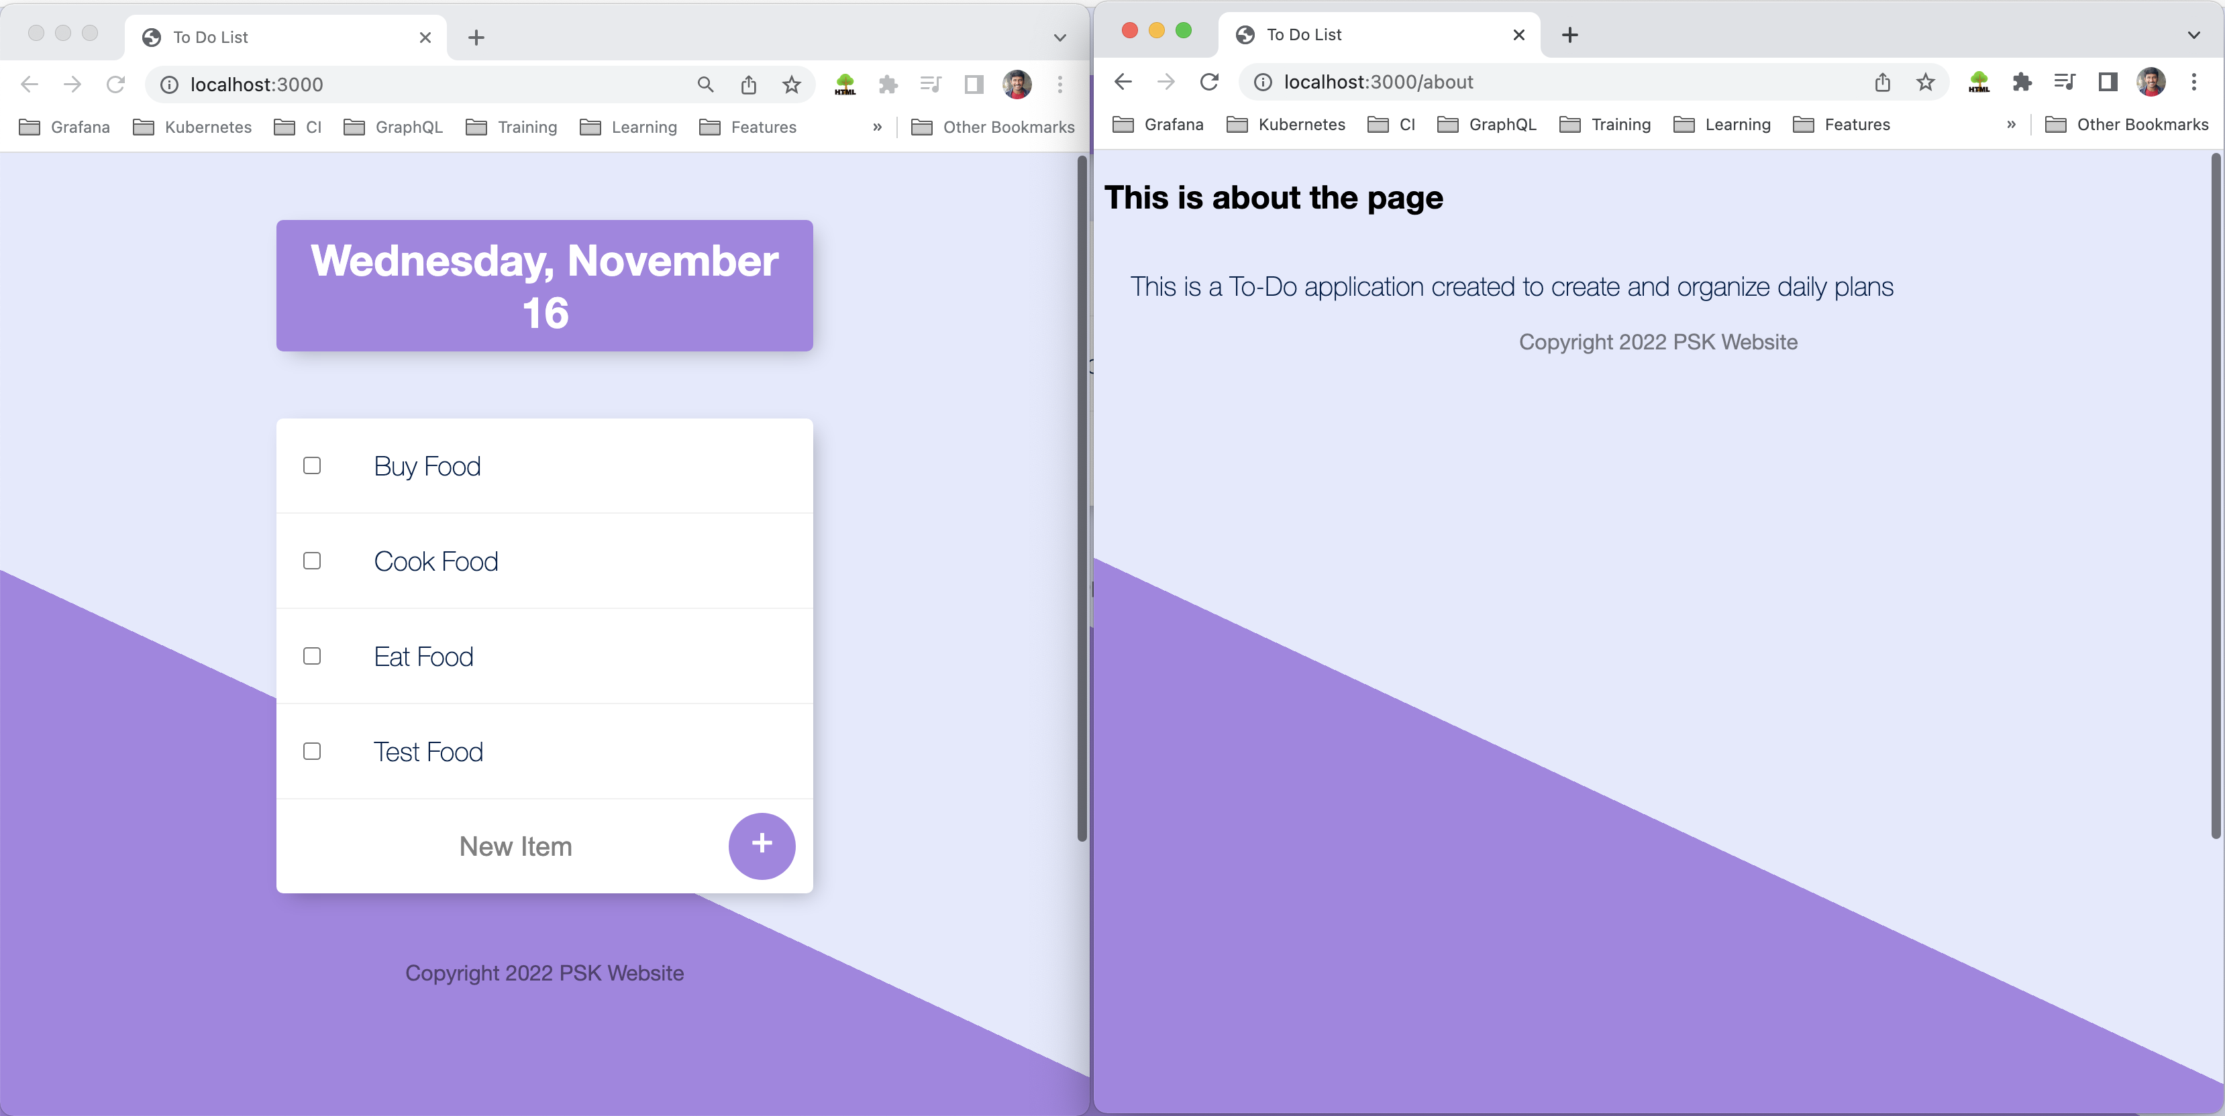

**Exporting single function:**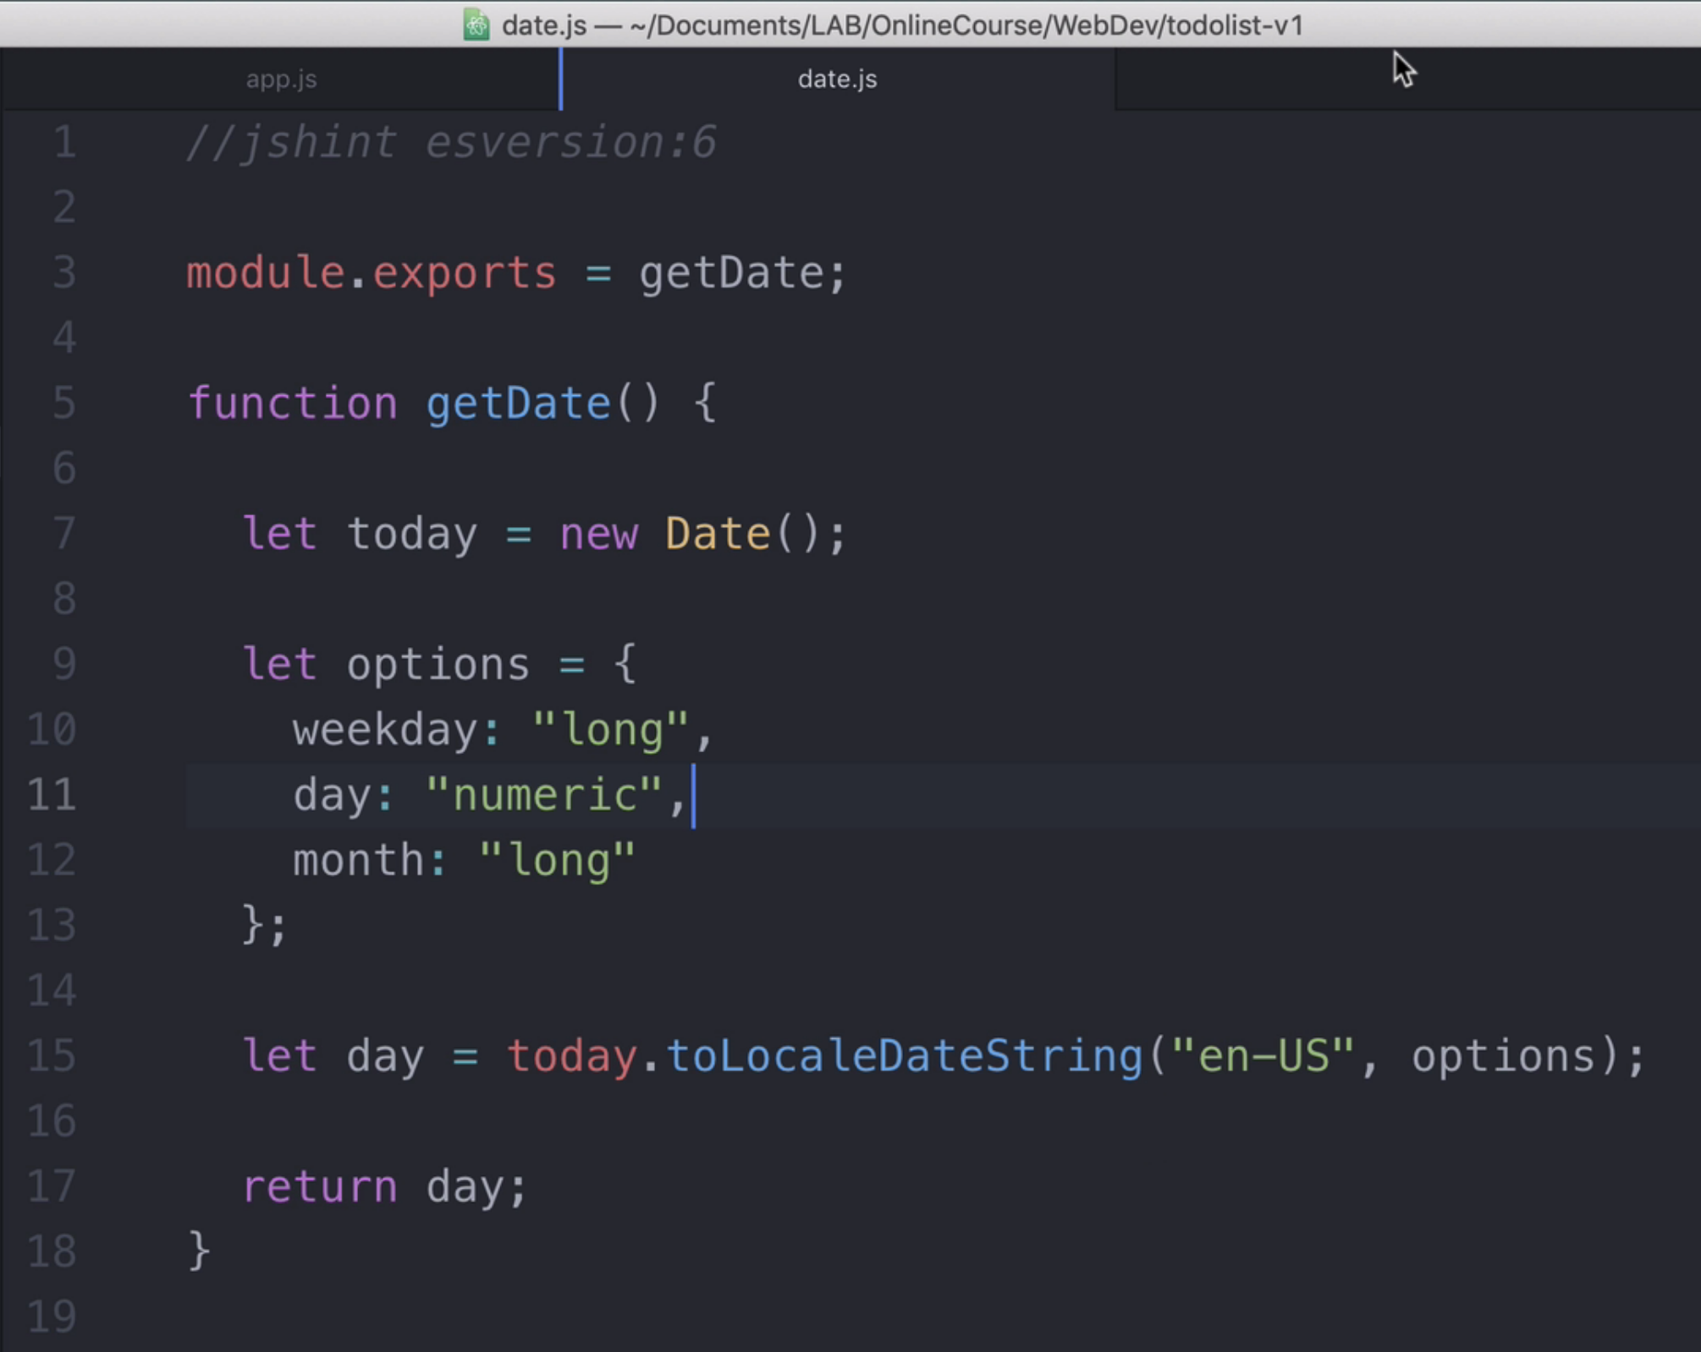

**Exporting multiple functions:**